Bloodgod - Dutch Death Metal Moloch
Biography  When writing a biography, bands and labels often indulge in hyperboles and onanism. Bloodgod likes things rather honest and fair. So here’s our story in short.  Hailing from Utrecht, the Netherlands, Bloodgod initially started low profile as a side project in late 2011 featuring former members of Warchitect, and Dictated among others.  After several changes in the line-up Bloodgod became a steady three-piece powerhouse, since 2013 featuring the same lineup consisting of:  - Daan Douma (Hymir) – guitars, lead vocals  - Frank van Boven (Disquiet) – bass, lead vocals  - Johnny Derechos (Nuestros Derechos, Agents of Entropy) – drums  The band delivers death metal with duo lead vocals. Often with a pinch of thrash, a drop of groove metal and a touch of black, always with melodic riffs and overall musical brutality. That might not be new or unique. But a classic dish that's cooked with skills and love can still make your mouth water, right?  'Pseudologia Phantastica’ (2013)  Bloodgod’s debut EP 'Pseudologia Phantastica’ was released in 2013. It was recorded and mixed by Quintijn Verhoef at Studio Independent Recordings (Incarnate, Led Astray, T.C.F., Terzij De Horde, Divine Sins, The Fifth Alliance, etc.) in Utrecht. It contains three death metal infused songs on which Bloodgod let their imagination run free, hence the title ‘Pseudologia Phantastica’.  Following the release of their debut EP, Bloodgod shared the stage with Can of Worms, Cryptopsy, Skeletal Remains, and Terrorizer among others, and played several national festivals including Big Ass Metal Fest, Angelfest Doetinchem and Frisian Brotherhood Fest.  'Catharsis' (2017)  The band’s second studio recording 'Catharsis' was released in 2017. Five brand new tracks were recorded and mixed at Mass Audio Studio in the Netherlands, and mastered by Grammy nominated engineer Jacob Hansen (Aborted, Mercenary, Volbeat, Pestilence, etc) in Denmark.  The artwork depicts ‘t Schrickelik Tempeest, meaning 'the horrible tempest' in old Dutch. It refers to the song with the same title and lyrics about the violent storm of August 1, 1674 that hit the episcopal cathedral in the band’s hometown Utrecht and turned it into ruins.  Bloodgod is ready to making a lasting impression on the scene. Shows in clubs and at festivals are booked for 2017 to unleash their brand of metal. Horns up! | Promo shot 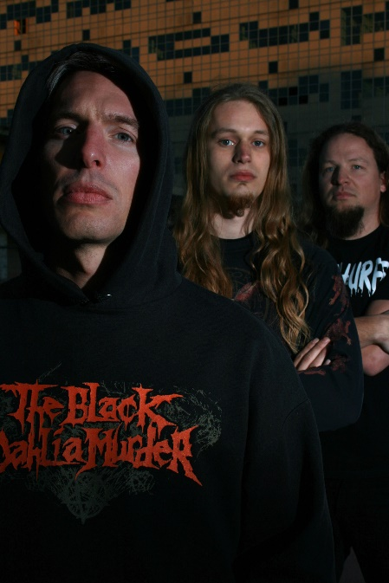  (Photo credit: Jerry van Vliet)  Discography  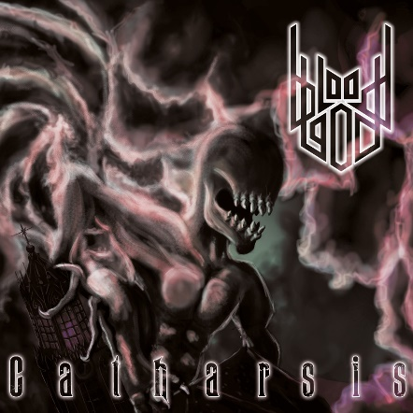  Catharsis, 2017  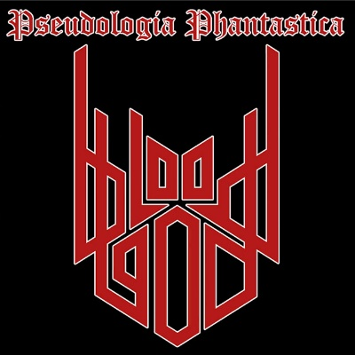  Pseudologia Phantastica, 2013  Contact info  info@bloodgod.nl  +31 6 225 46 554  Electronic press kit (EPK) bloodgod.nl/epk.html

